CAMPUS FIND: SMART CAMPUS LOST AND FOUND SYSTEM
A PROJECT REPORT
Submitted by
SACHIN KRISHNA B (241901507)
in partial fulfillment for the award of the degree of
BACHELOR OF ENGINEERING
in
COMPUTER SCIENCE AND ENGINEERING (CYBER SECURITY)

RAJALAKSHMI ENGINEERING COLLEGE
An Autonomous Institute
CHENNAI
NOVEMBER 2026

RAJALAKSHMI ENGINEERING COLLEGE CHENNAI
BONAFIDE CERTIFICATE

Certified that this Project report titled “CAMPUS FIND: SMART CAMPUS LOST AND FOUND SYSTEM” is the Bonafide work of Sachin Krishna B Register No:241901507 who carried out the work under my supervision. Certified further that to the best of my knowledge the work reported herein does not form part of any other project report or dissertation on the basis of which a degree or award was conferred on an earlier occasion on this or any other candidate.

SIGNATURE
Department of Computer Science and Engineering (Cyber Security)
Submitted to Project Viva-Voce Examination held on ____________________________

SIGNATURE OF THE INTERNAL EXAMINER

ABSTRACT
CampusFind is a full-stack web application designed to modernize lost-and-found coordination within a college campus. The system replaces scattered messaging groups, physical notice boards, and informal handovers with a centralized searchable feed for reporting, discovering, claiming, and resolving lost items. A React and Vite frontend provides a responsive dashboard with keyword search, item-type filters, category and location filters, status tracking, live recovery metrics, report forms, and a built-in project presentation mode. A Node.js and Express backend exposes REST APIs for item retrieval, item creation, ownership claims, lifecycle updates, statistics, and presentation content. The application stores records in a JSON data store and supports optional image uploads through Multer. To reduce fraudulent claims, found-item records include an ownership verification challenge; a claimant must provide a proof answer together with contact details before the item can be handed over. The system also calculates category and location summaries, displays recovery-rate analytics, and enables status transitions from active to claimed or returned. The project demonstrates how a focused campus workflow can be implemented using a decoupled client-server architecture, simple persistent storage, and security-aware interaction design. The resulting prototype is suitable for academic demonstration and provides a clear foundation for future additions such as campus single sign-on, notifications, image matching, and administrative moderation.

ACKNOWLEDGEMENT
First and foremost, we thank Almighty God for enabling us to complete this project successfully. We express our sincere gratitude to our Chairman, Mr. S. Meganathan, B.E., F.I.E., for his dedicated efforts in providing quality education at this esteemed institution. We are deeply grateful to our beloved Chairperson, Dr. Thangam Meganathan, Ph.D., for her constant motivation and encouragement, which inspired us throughout the completion of this project. We also thank our Vice Chairman, Mr. Abhay Shankar Meganathan, B.E., M.S., for providing the necessary infrastructure and facilities.
We express our sincere gratitude to our College Principal, Dr. S. N. Murugesan, M.E., Ph.D., and Dr. P. Tamilselvi, Ph.D., Professor and Head, Department of Computer Science and Engineering (Cyber Security), for their support and encouragement.
We are especially thankful to our project guide, , for her valuable guidance, continuous encouragement, and support throughout the project. Finally, we thank our parents and friends for their direct and indirect contributions, encouragement, and support in the successful completion of this project.

SACHIN KRISHNA B (241901507)

INDEX
Chapter / Section | Chapter or Section Name | Page
1 | INTRODUCTION | 1
1.1 | BACKGROUND | 1
1.2 | MOTIVATION | 1
1.3 | PROBLEM STATEMENT | 1
1.4 | OBJECTIVES OF THE PROJECT | 2
1.5 | SCOPE AND BOUNDARIES | 2
1.6 | REQUIREMENTS | 3
1.7 | SYSTEM CONSTRAINTS AND ASSUMPTIONS | 3
2 | SYSTEM STUDY AND ANALYSIS | 5
2.1 | EXISTING PRACTICE | 5
2.2 | PROPOSED SYSTEM | 5
2.3 | FEASIBILITY ANALYSIS | 6
2.4 | TECHNOLOGY STACK | 6
2.5 | USER ROLES AND USE CASES | 6
2.6 | USE CASE SCENARIOS | 7
3 | SYSTEM DESIGN | 8
3.1 | SYSTEM ARCHITECTURE | 8
3.2 | USER WORKFLOW | 8
3.3 | DATA MODEL | 9
3.4 | SECURITY AND VALIDATION | 9
3.5 | DATA VALIDATION RULES | 10
3.6 | DESIGN RATIONALE | 11
4 | IMPLEMENTATION | 12
4.1 | FRONTEND MODULES | 12
4.2 | BACKEND REST API | 12
4.3 | OWNERSHIP VERIFICATION | 13
4.4 | ANALYTICS AND PRESENTATION | 13
4.5 | DEPLOYMENT AND OPERATIONS | 14
5 | TESTING AND RESULTS | 16
5.1 | TEST STRATEGY | 16
5.2 | TEST CASES | 17
5.3 | RESULTS AND DISCUSSION | 17
5.4 | LIMITATIONS | 17
5.5 | PERFORMANCE AND QUALITY OBSERVATIONS | 18
5.6 | TEST DATA MANAGEMENT | 18
6 | CONCLUSION AND FUTURE ENHANCEMENTS | 19
6.1 | CONCLUSION | 19
6.2 | LEARNING OUTCOMES | 19
6.3 | CHALLENGES FACED | 19
6.4 | FUTURE ENHANCEMENTS | 19
6.5 | PROJECT OUTPUT | 20
 | REFERENCES | 21
 | APPENDIX A – API EXAMPLES | 22
 | APPENDIX B – ABBREVIATIONS | 23

LIST OF TABLES
Table Number | Table Name | Page
TABLE 1.1 | FUNCTIONAL REQUIREMENTS | 3
TABLE 1.2 | SYSTEM CONSTRAINTS AND ASSUMPTIONS | 3
TABLE 2.1 | EXISTING AND PROPOSED PRACTICE | 5
TABLE 2.2 | TECHNOLOGY STACK | 6
TABLE 2.3 | USER ROLES AND USE CASES | 7
TABLE 2.4 | USE CASE SCENARIOS | 7
TABLE 3.1 | DATA ENTITIES | 9
TABLE 3.2 | VALIDATION RULES | 10
TABLE 4.1 | REST API ENDPOINTS | 13
TABLE 4.2 | DEPLOYMENT AND OPERATIONS | 15
TABLE 5.1 | TEST CASES | 17
TABLE 5.2 | RESULTS SUMMARY | 17
TABLE 5.3 | PERFORMANCE AND QUALITY OBSERVATIONS | 18
TABLE 6.1 | FUTURE ENHANCEMENT ROADMAP | 20
TABLE B.1 | ABBREVIATIONS | 23

LIST OF FIGURES
Figure Number | Figure Name | Page
FIGURE 3.1 | SYSTEM ARCHITECTURE | 8
FIGURE 3.2 | LOST AND FOUND RECOVERY WORKFLOW | 9
FIGURE 3.3 | DATA VALIDATION AND OWNERSHIP CHECK | 10
FIGURE 4.1 | CAMPUSFIND DASHBOARD | 12
FIGURE 4.2 | RECOVERY ANALYTICS SNAPSHOT | 14
FIGURE 4.3 | CAMPUSFIND ITEM LIFECYCLE | 14

CHAPTER 1
INTRODUCTION

1.1 BACKGROUND
College campuses are active environments where students, faculty members, visitors, and support staff move between classrooms, laboratories, libraries, cafeterias, sports facilities, and transport areas. In this setting, personal belongings are frequently misplaced and then recovered by someone else. Although the problem is common, the recovery process is usually informal: a message is posted in a class group, a photo is shared in a social-media story, or an item is left at a security desk. These channels are fragmented, difficult to search, and not designed to verify ownership.
From a system perspective, the challenge is not only the absence of a notice board; it is the absence of structured information. A useful record must identify what was lost or found, where it was seen, when the event occurred, which category it belongs to, and how a genuine owner can prove a claim. CampusFind treats these details as data that can be indexed, filtered, and updated instead of as isolated messages.
CampusFind addresses this gap through a centralized web application that makes item records visible, searchable, and traceable. A user can report a lost item or a found item with descriptive fields such as title, category, campus location, date, description, contact details, and an image reference. Other users can filter the feed, inspect a relevant record, submit a lead or claim, and follow the item status until the recovery is complete.

1.2 MOTIVATION
The motivation for CampusFind is to make a routine campus problem easier to solve while preserving a safe handover process. A useful recovery platform must provide more than a public list of objects. It should reduce duplicate reports, help users find the right item quickly, distinguish lost records from found records, show where items are concentrated, and discourage false claims. The project therefore combines a simple search-and-filter experience with a challenge-response ownership question and a visible lifecycle status.
The project is also motivated by the need for a shared operational view. A student wants a quick answer to “has this been found?”, while a staff member needs to know which items remain active, which have a pending claim, and which have been returned. The same underlying data can support both needs when the interface presents the right level of detail at each step.

1.3 PROBLEM STATEMENT
Existing campus recovery practices do not provide a single source of truth for lost and found items. Users cannot reliably search earlier messages, compare nearby records, confirm whether an item is still available, or prove ownership before collecting it. Staff members also lack a lightweight way to observe recovery activity across categories and locations. The problem is to design and implement a web-based system that centralizes item reporting, supports fast discovery, verifies claims through item-specific proof, and tracks progress from report creation to return.
The problem can be divided into four connected questions: how to capture a report consistently, how to retrieve the right record quickly, how to verify that a claimant is genuine, and how to record the final outcome. If any one of these steps is missing, the system can still produce confusion even when the other steps work correctly. CampusFind therefore designs the complete path rather than treating search, claims, and status updates as separate features.

1.4 OBJECTIVES OF THE PROJECT
The objectives of CampusFind are to: (i) provide a centralized campus item feed; (ii) support separate lost and found reporting; (iii) implement instant keyword, category, location, and status filtering; (iv) collect ownership proof before a found item is handed over; (v) provide REST APIs for item, claim, status, statistics, and presentation operations; (vi) display recovery metrics and hotspot summaries; (vii) maintain a simple persistent JSON data store suitable for a mini-project prototype; and (viii) demonstrate a complete React–Express full-stack workflow.
These objectives combine user experience goals with implementation goals. The frontend must remain understandable to a first-time user, while the backend must expose predictable operations that can be tested independently. The project is successful when a record can be created, discovered, challenged, claimed, and resolved without requiring a separate communication channel.

1.5 SCOPE AND BOUNDARIES
The present project covers the web interface, REST API, JSON persistence, item lifecycle, claim submission, statistics, optional image upload support, and an in-app presentation viewer. It includes sample records for electronics, cards and IDs, books and stationery, keys and accessories, lab and clothing, and personal items across campus locations such as the Central Library, Main Cafeteria, Computer Center, Mechanical Block, Sports Complex, Auditorium, and Parking Bay B.
The scope also includes the design of a consistent vocabulary for categories, locations, and statuses. This vocabulary is important because the filters and analytics depend on values being entered consistently. The prototype uses controlled choices in the report form so that “Central Library” and “central library” do not become two unrelated analytical groups.
The prototype does not include institutional single sign-on, production-grade database replication, automated email or SMS notification, identity-document verification, administrator approval workflows, or computer-vision matching. These features are intentionally treated as future enhancements rather than claimed capabilities of the current implementation.
Requirement Type | Requirement
Functional | Create lost/found item reports with description, category, location, date, contact, and verification question.
Functional | Search and filter records by type, category, location, status, and keyword.
Functional | Submit ownership claims and update item status to claimed or returned.
Functional | Expose REST endpoints for items, claims, status, statistics, and slides.
Non-functional | Responsive interface, readable status labels, clear recovery workflow, and fast local filtering.
Non-functional | Input validation, safe file-size limits, CORS support, and simple persistent storage.

1.6 REQUIREMENTS
The functional requirements define the minimum behavior expected from the CampusFind prototype. They cover structured lost and found reporting, keyword and category-based discovery, ownership claims, lifecycle status updates, REST operations, responsive presentation, input validation, file-size limits, CORS support, and simple persistent storage.

1.7 SYSTEM CONSTRAINTS AND ASSUMPTIONS
The prototype is developed as an academic system with a deliberately narrow operational boundary. The design assumes that users have access to a modern browser, that the campus network can reach the application server, and that a report is created by a person who can provide enough detail for another person to recognize the item. These assumptions keep the first release understandable while still representing the essential recovery workflow.

The main technical constraint is the use of a JSON file as the persistence layer. This choice makes the dataset easy to inspect and reset during demonstrations, but it also means that concurrent writes, backup, indexing, and access control are not comparable to a production database. A second constraint is the absence of institutional identity integration. The current workflow therefore records contact information and proof answers without claiming that the user identity has been independently verified.

The constraints do not reduce the usefulness of the project as a mini-project. Instead, they clarify which behavior has been implemented and which behavior belongs to a future deployment. A clear boundary is important in a software report because it prevents prototype evidence from being interpreted as production certification.

Assumption / Constraint | Effect on Current Prototype | Design Response
Small academic dataset | Simple filtering is sufficient for the seeded records. | Keep queries readable and expose metrics for demonstration.
Local JSON persistence | Concurrent multi-user writes are limited. | Separate persistence logic so a database can replace it later.
No single sign-on | Identity is not independently authenticated. | Use contact details and item-specific proof for the prototype.
Optional item image | A listing may rely on text when no image is supplied. | Keep descriptive fields complete and make images supplementary.
Human-assisted handover | The system does not physically control the item exchange. | Record status and proof while leaving final handover to authorized people.
TABLE 1.2 SYSTEM CONSTRAINTS AND ASSUMPTIONS

CHAPTER 2
SYSTEM STUDY AND ANALYSIS

2.1 EXISTING PRACTICE
In the existing practice, a student may share a lost-item message in one group, while a finder may post a different message in another group. Information is quickly buried under unrelated messages, and there is no consistent format for title, location, date, or identifying details. A claimant may also contact a finder privately without providing evidence that the item belongs to them. This creates unnecessary effort and makes the handover process difficult to audit.
The absence of structured status is especially costly. A record may continue to circulate after the item has already been returned, causing duplicate enquiries and wasted time. Informal channels also make it difficult to distinguish a verified claim from a casual assertion. These shortcomings establish the need for a workflow in which every record has a current state and every claim is attached to a particular item.

2.2 PROPOSED SYSTEM
The proposed system presents all records in one campus feed. Each card shows whether the record is lost or found, its lifecycle status, category, location, date, description, and a verification prompt. Search and filters reduce the time needed to find a relevant record. A found-item claim is recorded against the item, which allows the poster or responsible staff member to compare proof before changing the status. The platform also computes summary metrics and exposes a presentation module for demonstration and viva use.
The feed is intentionally designed as a shared surface rather than as separate pages for every task. A lost-item reporter can see whether similar found records already exist, and a finder can check whether somebody has reported a matching loss. The same card structure also makes the system easier to demonstrate because the evaluator can follow one item through every state.

Aspect | Existing Practice | CampusFind
Discovery | Messages spread across groups and notice boards. | Central feed with keyword search and filters.
Record format | Free-form text; fields are inconsistent. | Structured title, type, category, location, date, description, and contact.
Ownership | Often based on informal conversation. | Challenge question plus claimant proof answer.
Status | Not reliably updated after recovery. | Active, claimed, and returned lifecycle states.
Monitoring | No consolidated view of campus activity. | Live totals, category counts, location hotspots, and recovery rate.
TABLE 2.1 EXISTING AND PROPOSED PRACTICE

2.3 FEASIBILITY ANALYSIS
Technical feasibility is high because the prototype uses widely supported web technologies and a small JSON data store. React and Vite support rapid interface development, while Node.js and Express provide a compact API layer. Operational feasibility is supported by a familiar card-based interface and a short recovery workflow that can be understood by students and staff without training. Economic feasibility is suitable for an academic prototype because the system can run locally without a paid database or external messaging service. The main deployment consideration is replacing JSON persistence with a controlled database before production use.
A practical deployment would place the frontend behind a web server and the API behind a process manager or container. The JSON store is useful for learning because it makes records easy to inspect, but a multi-user deployment would need transactions, backup, indexing, and access control. The prototype therefore demonstrates feasibility while clearly separating academic scope from production requirements.

2.4 TECHNOLOGY STACK
Layer | Technology | Use in CampusFind
Frontend | React, Vite, lucide-react | Single-page dashboard, modals, filters, cards, metrics, presentation viewer.
Backend | Node.js, Express | REST routes, JSON responses, status updates, file upload handling.
Persistence | JSON file store | Seeded item records, claim arrays, created timestamps, and lifecycle status.
Styling | CSS and responsive layout | Visual hierarchy, badges, cards, responsive grid, modals.
Presentation | pptxgenjs and slide JSON | Downloadable deck and in-app presentation mode.
TABLE 2.2 TECHNOLOGY STACK

2.5 USER ROLES AND USE CASES
CampusFind supports several user perspectives even though the prototype keeps the interface intentionally simple. A student who has lost an item needs quick discovery and a clear claim path. A student who has found an item needs a safe way to publish useful information without revealing every private detail. A staff member or security-desk operator needs a dependable record of the current state and a way to confirm that a handover has been completed.
The use cases are connected rather than isolated. Reporting creates the structured record, discovery reduces search effort, verification protects the handover, and resolution closes the lifecycle. This sequence also explains why status and claim data are stored with the item instead of being maintained in separate manual registers.

User Role | Primary Use Case | Information Needed | Expected Outcome
Reporter | Create a lost or found report. | Title, category, location, date, description, contact, verification question. | A complete searchable record is published.
Searcher | Find a relevant item quickly. | Keyword, type, category, location, and status filters. | Matching records remain visible and current.
Claimant | Submit ownership proof. | Claimant contact and item-specific proof answer. | A claim is attached to the correct item.
Finder / Staff | Review evidence and update status. | Item details, claim data, and handover outcome. | The item becomes claimed or returned.
Evaluator | Inspect project behavior and metrics. | Dashboard, statistics, API routes, and presentation mode. | The full workflow can be demonstrated and tested.
TABLE 2.3 USER ROLES AND USE CASES

2.6 USE CASE SCENARIOS
A lost-item scenario begins with a student entering a title, category, location, date, and description. The record appears in the shared feed and can be discovered by a person who has found a matching object. The student can compare visible details without needing to search through unrelated messages or remember which communication group contained the original notice.
A found-item scenario begins with a finder entering useful public details and a verification question. The finder does not need to publish every identifying detail. When a claimant submits an answer, the proof can be compared with the original record before the status changes. This protects the finder from handing an item to the first person who makes a general claim.
A staff-assisted scenario uses the same record but adds an operational role. A security-desk or department representative can review the claim, contact the relevant person, and mark the record as claimed or returned. The important design choice is that every participant acts on the same item identifier, so the final state remains visible to later reviewers.
Scenario | Starting Event | System Response | Completion Condition
Lost item recovery | Student reports a missing belonging. | Creates a searchable lost record and exposes filters. | Matching found record is identified and claim is submitted.
Found item publication | Finder submits an item with a private challenge. | Creates a found record without exposing every identifying detail. | Genuine claimant provides acceptable proof.
Claim review | Claimant opens a found item and submits contact plus proof. | Stores the claim against the item and refreshes the feed. | Finder or staff accepts or rejects the claim.
Operational monitoring | Staff reviews dashboard metrics. | Aggregates totals, categories, locations, and recovery rate. | Campus team sees where follow-up effort is needed.
TABLE 2.4 USE CASE SCENARIOS
CHAPTER 3
SYSTEM DESIGN

3.1 SYSTEM ARCHITECTURE
CampusFind follows a decoupled client-server architecture. The browser renders the React single-page application and sends JSON requests to the Express API. The server reads and writes item data, calculates statistics, handles claim and status updates, and serves the generated presentation file. This separation keeps interface concerns independent from data operations and makes it possible to replace the JSON store with a database later.
A typical request starts with a user action such as changing a filter or submitting a claim. React builds the query or request body, fetches the API response, updates local component state, and re-renders the relevant card or metric. The backend remains responsible for persistence and validation, which prevents the interface from becoming the source of truth for item status.
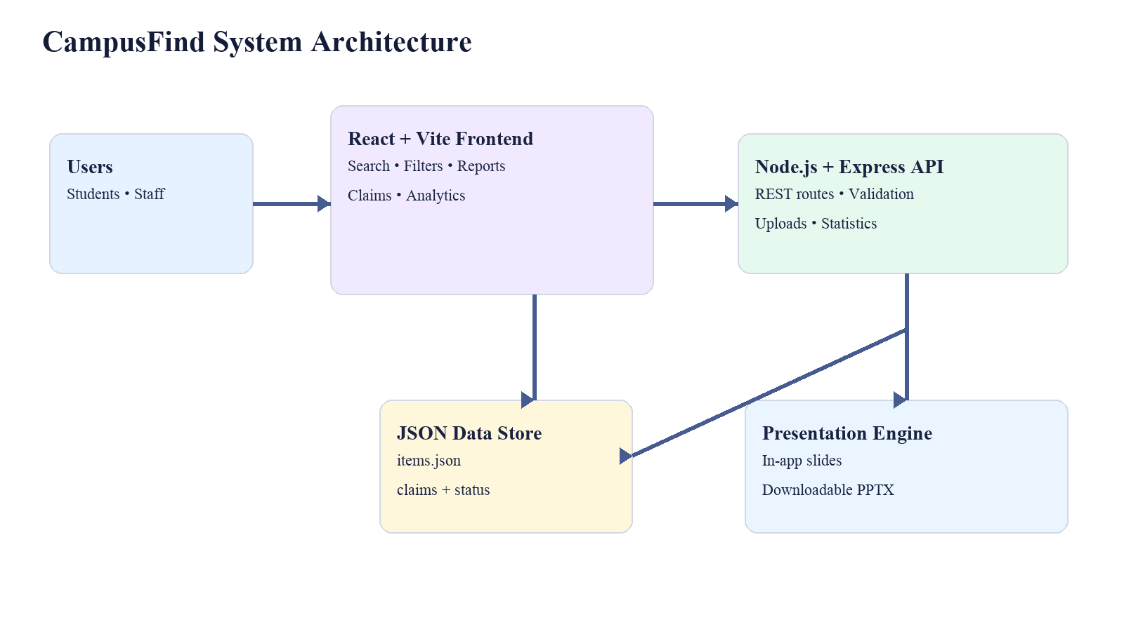
FIGURE 3.1 SYSTEM ARCHITECTURE

3.2 USER WORKFLOW
The recovery workflow begins when a user reports a lost or found item. The feed then becomes the shared discovery surface. A user can search by text or narrow results by item type, category, location, and status. For a found item, the claimant selects the record and answers the verification question. The system records the claim and the responsible user can update the item state when the proof is accepted. The status change is reflected in the feed and analytics.
The workflow supports two common entry points. A person who lost an item starts with a description and later searches for a matching found record. A person who found an item starts by posting it with a challenge question and waits for a claimant. Both paths converge on the same item record, which avoids maintaining separate manual registers for lost and found reports.
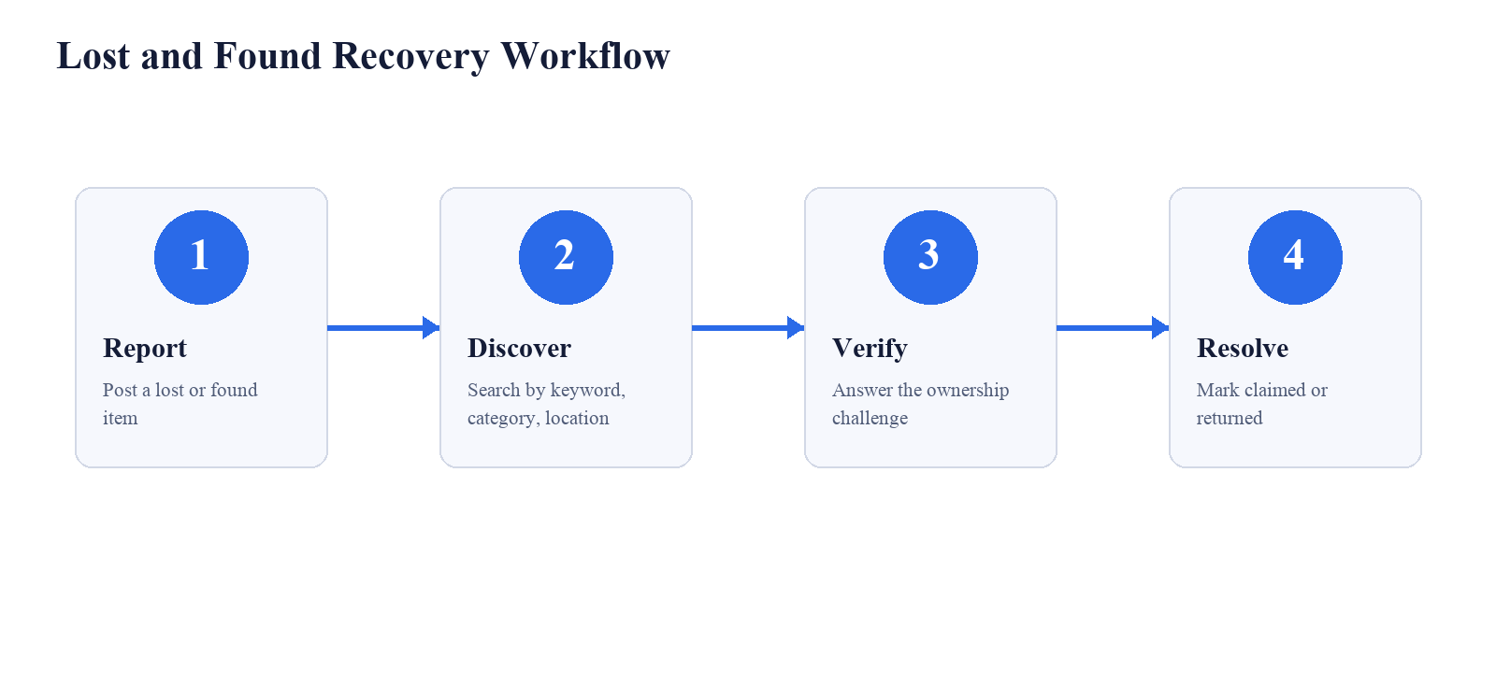
FIGURE 3.2 LOST AND FOUND RECOVERY WORKFLOW

3.3 DATA MODEL
The central item record is intentionally small and readable. It contains the fields required to display a useful listing and to complete a handover. Claims are stored as an array within the item record in the current prototype. Each claim includes claimant name, contact, proof answer, timestamp, and claim status. The model supports an iterative move toward normalized database tables without changing the user-facing workflow.
Entity / Field | Type | Purpose
Item.id | String | Stable identifier used by item and claim routes.
Item.type | Enum | Distinguishes lost and found records.
Item.category | String | Groups records for filtering and metrics.
Item.location | String | Stores the campus place where the item was lost or found.
Item.status | Enum | Tracks active, claimed, or returned state.
Item.verificationQuestion | String | Challenge prompt for ownership verification.
Item.claims | Array | Stores submitted proof and claim status.
Item.createdAt | ISO timestamp | Supports ordering and audit-style display.
TABLE 3.1 DATA ENTITIES

3.4 SECURITY AND VALIDATION
The ownership challenge is a practical safety control: the public description does not reveal every identifying detail, while the verification question asks for a detail that a genuine owner should know. The backend validates request bodies, limits uploaded files to 5 MB, uses a controlled upload directory, and returns explicit error messages for invalid operations. CORS is enabled for the local frontend during development. For production, the prototype would need authenticated roles, stronger input sanitization, audit logs, protected storage, and controlled contact disclosure.

3.5 DATA VALIDATION RULES
Validation is applied at the boundary between the user interface and the API. Required fields are checked before a report is created, enum-like values are restricted to supported types and statuses, and uploaded images are limited by file type and size. These controls reduce incomplete records and make the data model predictable for search, statistics, and presentation features.
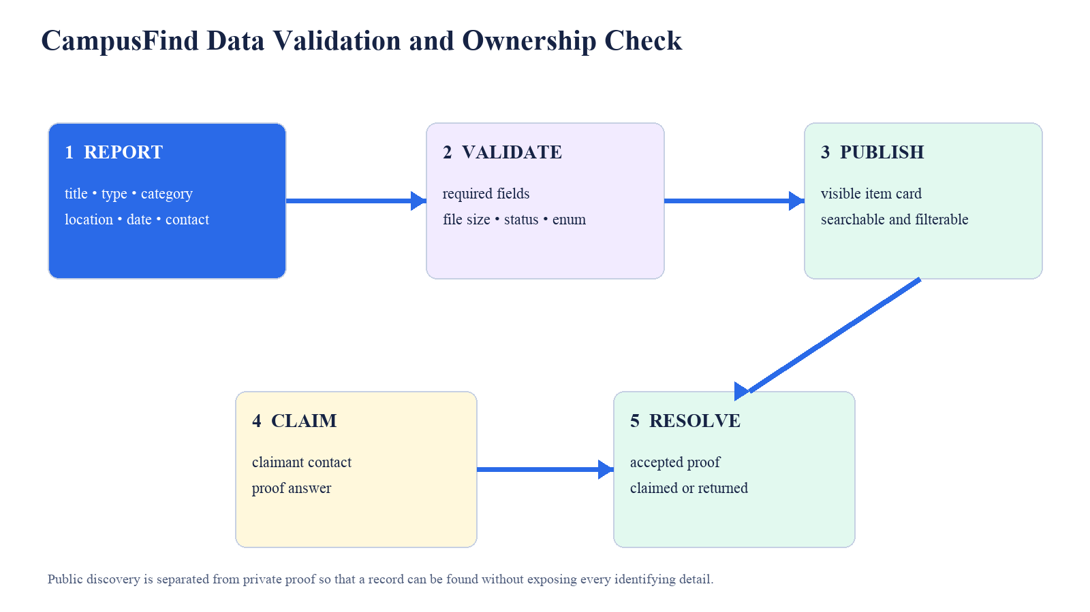
FIGURE 3.3 DATA VALIDATION AND OWNERSHIP CHECK
Rule | Validation Applied | Reason
Required report fields | Title, type, category, location, date, description, contact, and verification question must be present. | Prevents incomplete listings.
Controlled values | Type is lost/found; status is active/claimed/returned. | Keeps filters and lifecycle metrics consistent.
Upload safety | Only supported image types are accepted and file size is limited to 5 MB. | Reduces storage abuse and invalid media.
Claim proof | Claim includes claimant contact and an item-specific proof answer. | Creates evidence for handover decisions.
Status transition | Only an existing item can be claimed or returned. | Avoids orphan updates and incorrect totals.
TABLE 3.2 VALIDATION RULES
The challenge-response mechanism is deliberately lightweight rather than a replacement for institutional identity verification. It reduces casual false claims by requiring knowledge of a private detail, but the final handover should still be performed by the poster or an authorized campus desk. The design keeps the proof answer in the claim record so that a later review can explain why a claim was accepted or rejected.

3.6 DESIGN RATIONALE
The design favors a shared feed because lost and found reports are two sides of the same campus event. Separate registers would force users to decide where to search and would make it harder to notice that a found record corresponds to an earlier lost report. A common card structure makes the workflow easier to teach and gives the evaluator a consistent object to follow through each lifecycle state.
The interface and API also use explicit names for the same concepts. The item identifier links the feed, claims, status updates, and statistics. The category and location values are reused across filters and analytics. This consistency reduces translation work between the user interface and backend and lowers the risk that a visual label suggests a state that the API does not understand.
The final rationale is controlled complexity. The project includes enough structure to demonstrate validation, ownership, persistence, and analytics, but it avoids adding features that would hide the core learning outcomes. Authentication, database migration, notifications, and image matching are therefore described as later layers rather than mixed into the first prototype.

CHAPTER 4
IMPLEMENTATION

4.1 FRONTEND MODULES
The main React component coordinates the dashboard, data loading, filters, report modal, claim modal, item status actions, presentation mode, and toast notifications. The interface begins with a short project identity block and a hero section that explains the purpose of the system. Four metric cards expose total listings, active lost items, found items, and recovery rate. Below them, the feed presents each listing as a card with a visual, status badges, location, description, verification prompt, and action controls.
The frontend uses state variables for the current search term, selected filters, loaded items, statistics, selected item, and modal visibility. When a filter or search term changes, the item-fetching function constructs query parameters and refreshes the feed. Separate statistics and presentation requests keep the dashboard summary independent from the list query, so the metrics remain meaningful even when the user narrows the visible cards.
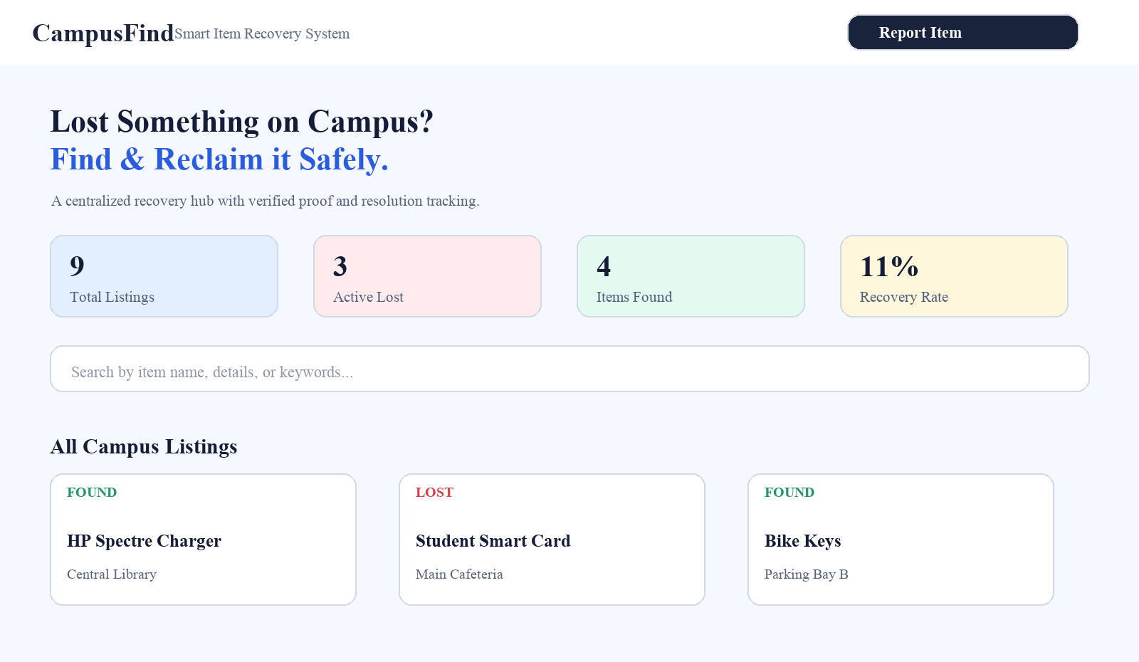
FIGURE 4.1 CAMPUSFIND DASHBOARD VISUAL

4.2 BACKEND REST API
The Express server defines a small set of routes that maps directly to the user workflow. GET routes read data and statistics, POST routes create reports and claims, and a PATCH route updates lifecycle status. The API also exposes the presentation slide JSON and the generated PPTX download. The use of resource-oriented routes keeps the prototype easy to test and easy to replace with a database-backed implementation later.
The API design uses the item identifier as the link between the feed and later actions. This makes claim submission and status updates explicit: a claim cannot be detached from the item it concerns, and a status update can be reflected immediately in the same card after the response is returned. The server also returns clear error responses when an item identifier is missing or an operation is not valid for the current state.
Method | Endpoint | Description
GET | /api/items | Returns items, with optional type, category, location, status, search, and sortBy filters.
GET | /api/items/:id | Returns one item with contact data and submitted claims.
POST | /api/items | Creates a lost or found report and persists it to the JSON store.
POST | /api/items/:id/claim | Adds an ownership claim with claimant details and proof answer.
PATCH | /api/items/:id/status | Updates the lifecycle status to active, claimed, or returned.
GET | /api/stats | Returns totals, recovery rate, category metrics, and location metrics.
GET | /api/presentation/slides | Returns the 10-slide presentation content.
GET | /api/presentation/download | Downloads Campus_Lost_and_Found_Project.pptx.
TABLE 4.1 REST API ENDPOINTS

4.3 OWNERSHIP VERIFICATION
The claim modal collects claimant name, contact information, and a proof answer. The answer is submitted to the item-specific claim route, appended to the record, and surfaced to the item owner or responsible contact. The interface then refreshes the feed and statistics. This flow separates discovery from handover: anyone may discover a record, but the resolution action remains tied to the verification evidence supplied by the claimant.
The verification question is created at report time, which allows the finder to choose an item-specific detail. For example, a finder may ask about a mark near a charger connector, the color of a lanyard, or an engraving on an accessory. Such questions are more useful than a generic “describe the item” prompt because they can test information that was not broadcast publicly.

4.4 ANALYTICS AND PRESENTATION
The statistics endpoint aggregates the current dataset into total count, active lost count, active found count, returned count, recovery rate, category counts, and location counts. The dashboard uses these values to explain campus activity at a glance. The presentation module makes the project demonstrable without leaving the application, while the backend also serves a downloadable PowerPoint deck for academic presentation.
The analytics are descriptive rather than predictive. They help a campus team see where reports are concentrated and how many records have reached a successful outcome. Because the values are computed from the same records shown in the feed, the dashboard avoids maintaining a second manual spreadsheet that could become inconsistent with the actual item state.
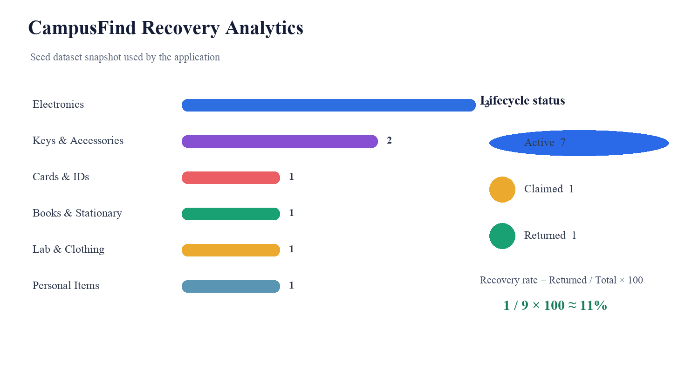
FIGURE 4.2 RECOVERY ANALYTICS SNAPSHOT

4.5 DEPLOYMENT AND OPERATIONS
For a classroom demonstration, the frontend can run through Vite while the Express server listens on the local API port. A practical campus deployment would place the frontend behind a web server, run the API under a process manager or container, and move item persistence to a relational database. Operational safeguards should include scheduled backups, structured logs, administrator roles, privacy-aware contact access, rate limiting, and monitoring for failed requests.
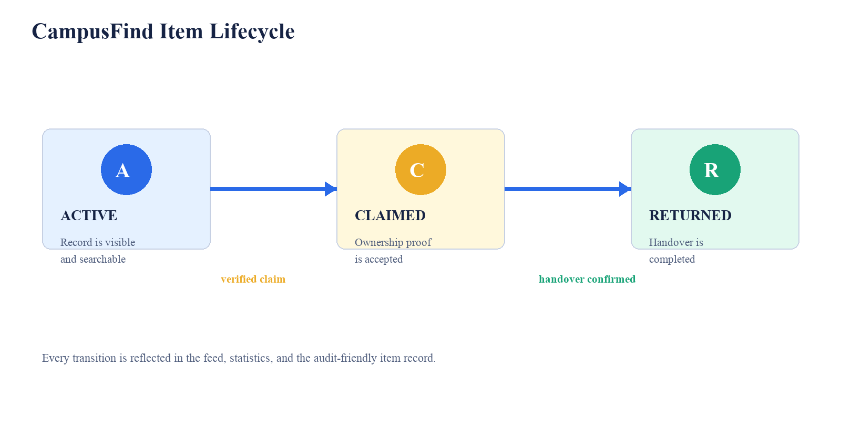
FIGURE 4.3 CAMPUSFIND ITEM LIFECYCLE

Operational Area | Prototype Approach | Recommended Deployment Practice
Hosting | Local Vite frontend and Node.js API. | Reverse proxy with HTTPS and managed service process.
Persistence | JSON file with seeded records. | Relational database with transactions, backup, and indexing.
Access control | Open prototype routes. | Single sign-on, role-based access, and protected contact data.
Monitoring | Health route and visible metrics. | Central logs, uptime checks, error alerts, and audit history.
Media handling | Local upload directory with size limit. | Object storage, virus scanning, retention policy, and signed access.
TABLE 4.2 DEPLOYMENT AND OPERATIONS

CHAPTER 5
TESTING AND RESULTS

5.1 TEST STRATEGY
Testing was organized around the user-visible workflow and the API actions behind it. The frontend was checked for initial loading, filtering, card rendering, modal open and close behavior, claim submission feedback, status updates, and presentation access. The backend was checked through its health, item, claim, status, statistics, and presentation routes. The seeded dataset provided a stable basis for checking counts and status transitions.
The testing approach combines positive and negative cases. Positive cases confirm that valid reports, claims, filters, and status changes work as intended. Negative cases confirm that missing claim fields and invalid operations are rejected with feedback rather than silently changing the dataset. This distinction is important for a recovery system because incorrect updates can mislead users even when the page itself remains available.
ID | Test Scenario | Expected Result | Observed Result | Status
TC-01 | Open the application with the backend running. | Dashboard loads with item cards and metrics. | Dashboard rendered with 9 listings. | Pass
TC-02 | Search for “charger”. | Only matching item records are shown. | HP Spectre charger record displayed. | Pass
TC-03 | Filter by Found Items. | Lost records are removed from the feed. | Found records remained visible. | Pass
TC-04 | Filter by campus location. | Records outside the selected location are hidden. | Location filter narrowed results. | Pass
TC-05 | Open a found item claim flow. | Claim form shows required proof fields. | Claim form opened with challenge question. | Pass
TC-06 | Submit an incomplete claim. | Submission is rejected with validation feedback. | Required-field validation displayed. | Pass
TC-07 | Submit a valid claim. | Claim is persisted and feed refreshes. | Claim route accepted record and refreshed data. | Pass
TC-08 | Mark a record as returned. | Status becomes returned and metrics update. | Returned state reflected in feed. | Pass
TC-09 | Open Project Presentation. | Interactive slide viewer loads. | Slide deck opened from API data. | Pass
TC-10 | Download PPTX. | PowerPoint file is served by backend. | Download route exposed successfully. | Pass

5.2 TEST CASES
TABLE 5.1 TEST CASES

5.3 RESULTS AND DISCUSSION
The seeded dataset contains nine listings distributed across six item categories and several campus locations. At the snapshot used for this report, one record is returned, one is claimed, and the remaining records are active. The dashboard therefore communicates both the volume of reports and the small number of successful resolutions. The visual summaries make the prototype’s value easy to demonstrate during evaluation: an assessor can see how a record is found, how proof is collected, and how the status transition changes the feed.
The results show that the prototype is functionally complete for its intended academic scope. The most visible benefit is reduced search effort: a user can combine a keyword with category, location, and status filters instead of scanning unrelated messages. The second benefit is traceability: the claim and final status remain associated with the item, making the resolution path easier to explain.

Metric | Snapshot Value | Interpretation
Total listings | 9 | Records available in the seeded campus feed.
Active lost | 3 | Items still reported as missing.
Items found | 4 | Found records currently visible in the feed.
Claim pending / claimed | 1 | A found item has an ownership claim in progress.
Returned | 1 | One item has completed the recovery lifecycle.
Recovery rate | 11% | Returned records divided by total records.
TABLE 5.2 RESULTS SUMMARY

5.4 LIMITATIONS
The evaluation uses a local prototype and seeded records, so the results measure functional completeness rather than campus-wide operational performance. The JSON store is appropriate for demonstration but would require locking, backup, and database indexing for concurrent users. Contact details are visible in the sample records and would need privacy-aware access controls in a deployed system. The project’s next testing stage should include concurrency, accessibility, security, upload validation, and persistence recovery tests.
The limitations also define a practical roadmap. A relational database would support concurrent writes and history tables, while authentication would reduce the risk of unauthorized status changes. Operational testing with real campus users would be needed to evaluate report quality, question quality, response time, and the clarity of the handover instructions.

5.5 PERFORMANCE AND QUALITY OBSERVATIONS
The prototype is designed for a small campus dataset, so the dominant performance cost is the clarity of the interaction rather than large-scale computation. Filtering combines the search term with the selected type, category, location, and status before the result cards are rendered. The statistics request is kept separate from the item query so that dashboard totals continue to describe the full dataset even when the user narrows the visible feed.
Quality was also considered through consistency and recovery behavior. Empty search results are represented as a meaningful state, validation messages are shown near the relevant form, and status changes are reflected in the same feed used for discovery. These choices reduce ambiguity for first-time users and make the application easier to evaluate during a demonstration.

Quality Dimension | Observation in Prototype | Improvement for Production
Responsiveness | Filtering and card rendering are suitable for the seeded dataset. | Add indexed queries and pagination for a larger campus dataset.
Reliability | Health route and explicit API errors expose basic service state. | Add retries, centralized logs, backups, and alerting.
Accessibility | Clear labels, status badges, and readable card hierarchy are provided. | Add keyboard testing, screen-reader labels, contrast checks, and focus management.
Security | Proof questions, validation, file-size limits, and controlled statuses are used. | Add authentication, authorization, rate limiting, and audit trails.
Maintainability | Frontend and backend responsibilities are separated by REST routes. | Add automated tests, database migrations, and deployment documentation.
TABLE 5.3 PERFORMANCE AND QUALITY OBSERVATIONS

5.6 TEST DATA MANAGEMENT
The seeded dataset is treated as a repeatable fixture for demonstrations. It includes a mixture of lost and found items, multiple categories, several campus locations, and more than one lifecycle state. This variety allows the same dataset to exercise keyword matching, type filters, status filters, category summaries, location summaries, claim handling, and recovery-rate calculation.

CHAPTER 6
CONCLUSION AND FUTURE ENHANCEMENTS

6.1 CONCLUSION
CampusFind demonstrates a focused and practical solution for campus lost-and-found coordination. The project connects a responsive React interface to an Express REST API and a persistent JSON store, creating a complete workflow for reporting, searching, claiming, and resolving items. Its most important design contribution is the ownership challenge, which adds a lightweight verification step without making the discovery process difficult. The live metrics and presentation mode further strengthen the system as an academic mini-project and as a starting point for a production campus service.
The project shows that a small, well-defined domain can benefit from full-stack design principles: structured records improve retrieval, explicit state improves coordination, and a verification step improves trust. The final prototype is not intended to replace campus administration, but it provides a clear digital layer that can organize the first stages of recovery and make the final handover easier to manage.

6.2 LEARNING OUTCOMES
The project provided experience in component-based frontend development, asynchronous data loading, REST endpoint design, JSON persistence, form validation, status-driven user interfaces, file-upload configuration, and presentation automation. It also reinforced the importance of separating public discovery information from private proof information, designing explicit lifecycle states, and testing user flows end to end.

6.3 CHALLENGES FACED
The main challenges were coordinating asynchronous frontend refreshes after claims and status updates, keeping filter combinations consistent with backend query parameters, maintaining readable cards across different item descriptions, and presenting recovery metrics that remained understandable as data changed. Another challenge was balancing a simple prototype data store with a workflow that demonstrates realistic records and handover decisions.

6.4 FUTURE ENHANCEMENTS
Future versions can add institutional single sign-on, administrator and security-desk roles, email or push notifications, a relational database, audit logging, moderation, and privacy-aware contact exchange. Image similarity can help match a newly found item to a lost report, while a map view can visualize campus hotspots. Smart lockers or QR-coded collection receipts could make handovers more accountable. A production release should also add accessibility testing, rate limiting, secure secrets management, encrypted storage, and automated backups.
Future work can be staged incrementally. The first release could add authentication, moderation, and notifications without changing the existing item model. The next release could add image matching and a map view. A later institutional release could connect CampusFind to campus identity services, help-desk workflows, and secure collection points.
Release Stage | Enhancement | Expected Benefit
Stage 1 | Authentication, moderation, and role-based access. | Protects contact data and reduces unauthorized updates.
Stage 2 | Notifications and secure collection scheduling. | Improves response time and makes handover predictable.
Stage 3 | Image similarity and campus map view. | Supports faster matching and location-based discovery.
Stage 4 | Institutional database, backups, and audit reporting. | Enables reliable multi-user operation at campus scale.
TABLE 6.1 FUTURE ENHANCEMENT ROADMAP

6.5 PROJECT OUTPUT
The completed project output includes the CampusFind React frontend, the Node.js and Express backend, seeded item data, REST API routes, dynamic dashboard metrics, the ownership verification workflow, and a generated PowerPoint presentation. The report documents the architecture, design decisions, implementation, and test evidence for the prototype.

REFERENCES
The references below support the technologies, web standards, security guidance, and project source materials discussed in this report. The project-source entry identifies the implementation files used to describe the CampusFind prototype.
1. React Documentation, “React: The library for web and native user interfaces,” react.dev.
2. Vite Documentation, “Vite: Next Generation Frontend Tooling,” vite.dev.
3. Express Documentation, “Fast, unopinionated, minimalist web framework for Node.js,” expressjs.com.
4. Node.js Documentation, “Node.js JavaScript runtime,” nodejs.org.
5. MDN Web Docs, “Using Fetch, Forms, and HTTP,” developer.mozilla.org.
6. OWASP Foundation, “Application Security Verification Standard,” owasp.org/www-project-application-security-verification-standard.
7. NIST, “Digital Identity Guidelines and Authentication,” National Institute of Standards and Technology.
8. Project source files: frontend/src/App.jsx, backend/server.js, backend/data/items.json, and README.md.

APPENDIX A – API EXAMPLES
This appendix gives representative requests and response fields for the REST API described in the implementation chapter. The examples correspond to item retrieval, claim submission, status updates, and the service health check.

A.1 LIST ITEMS
GET http://localhost:5001/api/items?type=found&location=Central%20Library
Example response fields: id, title, type, category, location, date, description, status, contactName, contactInfo, verificationQuestion, imageUrl, claims, and createdAt.

A.2 SUBMIT A CLAIM
POST /api/items/item_001/claim
{ "claimantName": "Student Name", "claimantContact": "student@example.edu", "proofAnswer": "Description known only to the owner" }

A.3 UPDATE STATUS
PATCH /api/items/item_001/status
{ "status": "returned" }

A.4 HEALTH CHECK
GET /api/health returns the service status and a timestamp, allowing the frontend or a deployment monitor to verify that the API is running.

APPENDIX B – ABBREVIATIONS
The abbreviations in this table are used throughout the report to describe the frontend, backend, data format, API design, and presentation output of CampusFind.
Abbreviation | Expansion | Context
API | Application Programming Interface | Routes exposed by the backend.
CORS | Cross-Origin Resource Sharing | Allows the local frontend to call the API during development.
CSS | Cascading Style Sheets | Styles the responsive dashboard.
HTTP | Hypertext Transfer Protocol | Transport used by REST requests.
JSON | JavaScript Object Notation | Data format for API responses and persistence.
PPTX | PowerPoint Open XML Presentation | Downloadable project presentation format.
REST | Representational State Transfer | Resource-oriented API design style.
UI | User Interface | Visible dashboard and interaction surfaces.
URL | Uniform Resource Locator | Address used for API and frontend resources.
Vite | Frontend build and development tool | Serves and bundles the React application.
TABLE B.1 ABBREVIATIONS

